Asssignment 4
Albert Abraham(3985)

1. How are inline and block elements different from each other?

Answer: Inline Elements: Inline Elements are the Elements that can appear in the body of an HTML page. They only take the space of the contents stored in it.
For Example: <span></span>

Block Elements:Block Elements are the Elements that take the whole space of the parent container.
For Example: <div></div>

CSS properties used to change the properties of these Elements are:

display:block;
display:inline:
display:inline-block:
display:none;

2.Explain the difference between visibility:hidden and display:none

Answer: visiblity:hidden : It is the property used in css. If it is used then the Content in this tag is not visible on the webpage, but space is allocated for it on the page.
For Example: we can use this with any tag-
visibility:hidden;

display:none : It is the property used in css.If it is used then the contents in this tag will not appear on the page at all . There will be no space allocated for it between the other tags.
For Example: we can use this with any tag-
display:none;

3. Explain the clear and float properties.

Answer: float:-The float property is used for positioning and formatting content.
The float property can have any of the following values:-
- Left-> The element floats to the left of its container.Eg-float:left;
- Right-> The element floats to the right of its container.Eg-float:right;
- none-> The element does not float (will be displayed just where it occurs in the text). This is default.Eg-float:none;

clear: The clear property specifies what element can float beside the cleared element and on which side.
The clear property can have any of the following values:-
- none-> Allows floating elements on both sides. This is default.Eg-clear:none;
- left-> No floating elements allowed on the left side.Eg-clear:left
- right-> No floating elements allowed on the right side.Eg-clear:right
- both-> No floating elements allowed on either the left or the right side.
Eg-clear:both;

4. Explain difference between absolute, relative,fixed and static.

Answer: absolute- An element witth position:absolute; is positioned relative to the nearest positioned ancestor.However if an absolute positioned element has no positioned ancestors, it uses the document body and moves along with page scrolling.
For Example: position:absolute;

relative: An element with position:relative; is positioned relative to it’s normal position.Setting the top,right,bottom and left properties will cause it to be adjusted away from it,s normal position. Other content will not be adjusted to fit into any gap left by the element.

5. Write the HTML code to create a table in which there are 4 columns( ID , Employee Name, Designation, Department) and at least 6 rows. Also do some styling to it.

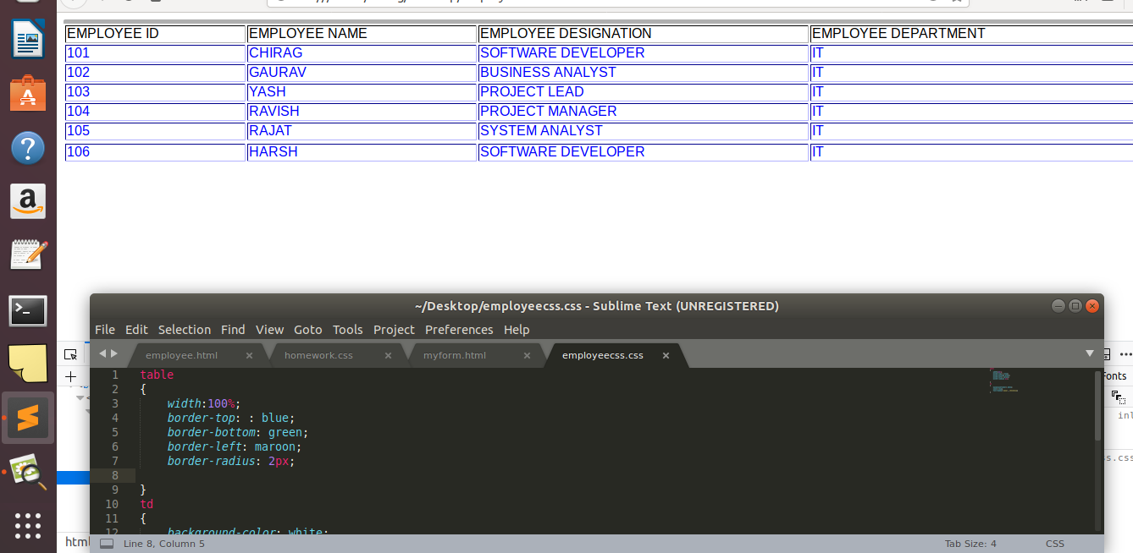

6. Why do we use meta tags?
Answer: The meta tags are the tags with contain additional information about the data. This tag is a self closing tag and this tag does not effect the working of an html document.
It has various attributes which provide the details of the contents. These Attributes are:-
- Name: Name for the property. Can be anything. Examples include, keywords, description, author, revised, generator etc.
- Content: It specifies the properties value.
- Scheme: Specifies a scheme to interpret the property's value.
- http-equiv: Used for http response message headers. For example, http-equiv can be used to refresh the page or to set a cookie. Values include content-type, expires, refresh and set-cookie.

For Example: <meta name=”Keywords” content=”HTML,meta Tags,Metadata”>

7. Explain box model.

Answer: Every document represents each element as a rectangular box according to the standard CSS box Model.CSS determines the size,position and properties(color,background,border size,etc) of these boxes.

Margin

Border
Padding

Content

- Content - The content of the box, where text and images appear.
- Padding- clears an area around content.The padding is transparent.
- Border- A border that goes around the padding and content.
- Margin- Clears an area outside the border. The margin is transparent.

8. What are the different types of CSS Selectors?
Answer: CSS selectors are used to select the HTML elements you want to style.
The different types of CSS Selectors are:-
- Element Selector.
- Id Selector
- Class Selector
- Group Selector
Element selector:- The Element Selects HTML Elements based on HTML name.
For Example: h1{
color:blue;
text-align:center;
}
Id selector :- The id selector selects HTML Elements based on id attribute of HTML Elements.
For Example: #para1{
color:blue;
text-align:center;
}
Class selector :- The class selector selects HTML Elements based on class attribute of HTML Elements.

For Example: .para1{
color:blue;
text-align:center;
}
Group selector :- The Group selector selects HTML Elements based on a particular group of HTML Elements.
For Example: h1,h2,p{
color:blue;
text-align:center;
}

9. Define Doctype.
Answer: A doctype stands for document type declaration is an instruction which tells the web browser about the markup language in which the current page is written. The doctype is not an element or tag, it lets the browser know about the version of or standard of HTML.
It appears ate the top of the html document before any other tag.
Syntax: < !DOCTYPE html >

10. Explain 5 HTML5 semantic tags.
Answer: The 5 HTML5 semantics tags are:-
- <article>:-The <article> element specifies independent, self-contained content. An article is a tag which make every section to read independently from rest of the website.
For Example:- <article>
<h1>Student</h1>
<p>This is article section.</p>
</article>
- <header>:- The <header> element specifies a header for a document or section.It is used as a container for introductory content.
For Example:- <article>
<header>
<h1>Databases</h1>
<p>A1 table</p>
</header>
<p>A1 table contains data of the students passed in mathmatics.</p>
</article>
- <footer>:- The <footer> element specifies a footer for a document or section. It is basically contains the author of the document,copyright information,links to terms of use,contact information, etc.
For Example: <footer>
<p>Posted by ToTheNew</p>
<p>Copyright@tothenew</p>
</footer>
- <nav>:- The <nav> element defines a set of navigation links.
For Example: <nav>
<a href=”/html/”>HTML</a>
<a href=”/CSS/”>CSS</a>
<a href=”/Javascript/”>Javascript</a>
<a href=”/Jquery/”>Jquery</a>
</nav>
- <main>:- The <main> tag specifies the main content of the document.
For Example: <main>
<h1>Web Browser</h1>
<p>Google Chrome ,Internet explorer and Firefox are the web browsers are commonly used web browser.</p>
</main>

11. Create HTML for web-page.jpg
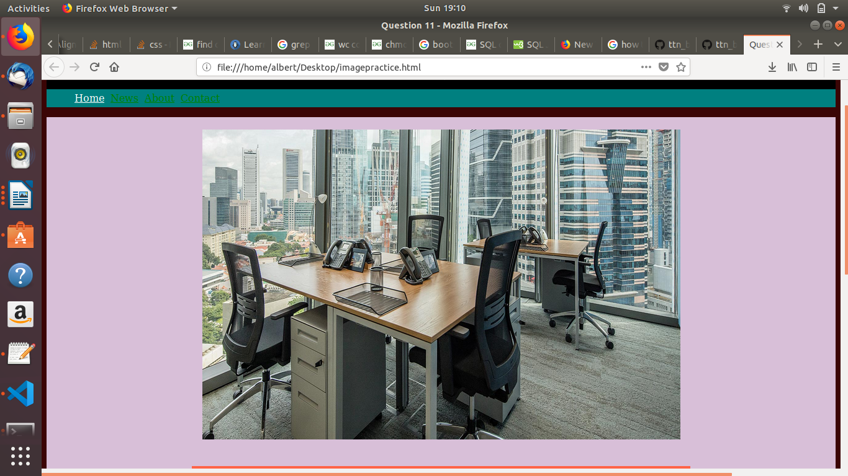

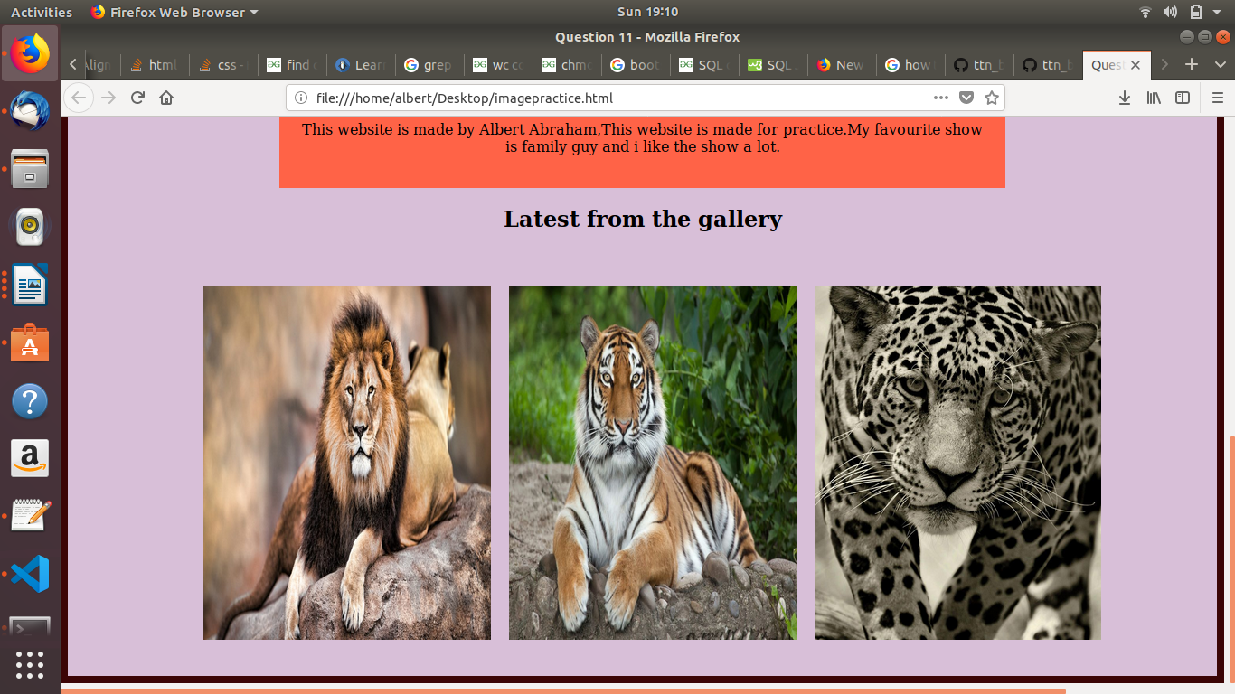

12. Create HTML for form.png

